Wednesday 2.30PM Tutorial

Member 1: Dang Khoa Le

Student ID: 103844421

Member 2: Saw Ko Ko Oo

Student ID: 104150310

Propositional Logic Inference Engine Report

Assignment 2 – COS30019 Introduction to Artificial Intelligence

Table of Contents

A. Summary 2

B. Instructions 2

C. Introduction 2

**1. Propositional Logic Inference Engine** 2

**2. Logical Connectives and Models** 3

**3. Alternative Operators** 3

D. Inference Methods 4

**1. Truth Table (TT)** 4

**2. Forward Chaining (FC)** 4

**3. Backward Chaining (BC)** 5

E. Implementation 6

**1. Main Script (inference.py)** 6

a. Truth Table Parsing (table_reader) 6

b. Generate a Truth Table (generate_truth_table) 7

c. Regular Truth Table Execution (truth_table) 7

d. Generic Truth Table Execution – with bracket rules (generic_truth_table, evaluate_condition) 8

e. Forward and Backward Chain Parsing (chain_reader) 10

f. Forward Chain Execution (forward_chain) 11

g. Backward Chain Execution (backward_chain) 11

h. Main Operator 12

**2. Sequence Handling (sequence.py)** 13

a. Truth Table Operator Handler (operator_table) 13

b. Forward and Backward Chaining Operator Handler (operator_chain) 16

c. Truth Table Operator Handler with Bracket Rule applied (generic_operator_table) 17

F. Testing 17

G. Features/Bugs/Missing 18

**1. Features** 18

**2. Bugs** 18

**3. Missing Features** 18

H. Research 19

I. Team Summary Report 22

J. Conclusion 22

K. Acknowledgements/Resources 22

L. References 22

# **A. Summary**

This report presents the implementation of an inference engine for propositional logic using three different algorithms: Truth Table (TT) checking, Forward Chaining (FC), and Backward Chaining (BC), as well as the research method Davis-Putnam-Logemann-Loveland (DPLL). The engine processes a Knowledge Base (KB) written in Horn form for Forward Chaining and Backward Chaining algorithms alongside with any generic form for Truth Table method, and DPLL-formatted (or conjunctive normal form, with binary-tree structure) test case for the Davis-Putnam-Logemann-Loveland algorithm. It answers whether a given query is entailed by the KB. Each algorithm offers unique advantages and is suited to different types of KBs, providing a comprehensive toolkit for propositional logic inference.

# **B. Instructions**

To use the program, follow these steps:

1. 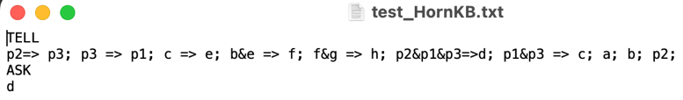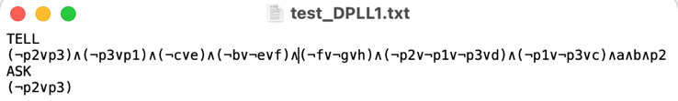Prepare text case file containing the KB and query in the specified format, TELL and ASK. Notice that the test case must be in Horn form for Forward Chaining (FC) and Backward Chaining (BC), and DPLL-formatted test case for Davis-Putnam-Logemann-Loveland method.

Figure. Example text file - test case with DPLL format.

Figure. Example text file - test case with Horn-form format.

**Notice:** Horn-form test case can’t contain negation and disjunction operators. DPLL test case must contain bracket separating each clause with proper logic defined.

1. Run the program from command line with filename and desired method (TT, FC, BC, or DPLL).

Terminal command console input must be format as:

python inference.py <filename> <method>

Where ‘inference.py’ the main program with the parameters, ‘filename’ is for the text file consisting of the problem, and ‘method’ can be either TT (for Truth Table checking), FC (for Forward Chaining), BC (for Backward Chaining), or DPLL (for Davis-Putnam-Logemann-Loveland) to specify the algorithm.

Terminal command console output will be format as:

****a. YES, followed by a colon (:) and the number of models of KB for TT method when the test case is valid (the query is entailed).

Figure. Example of a console line using Truth Table method.

****b. YES, followed by a colon (:) and the list of propositional symbols entailed from KB for FC and BC methods when the test case is valid (the query is entailed).

Figure. Example of a console line using Backward Chaining method.

c. YES for DPLL method returning whether the query is entailed.

d. NO, if the test case return invalid.

# **C. Introduction**

## **1. Propositional Logic Inference Engine**

The Propositional Logic Inference Engine determines whether a proposition (query) is entailed from a set of premises (KB). It uses logical connectives such as conjunction (&), disjunction (||), negation (~), implication (=>), deduction (<=), and biconditional (<->).

## **2. Logical Connectives and Models**

* **Conjunction (&)**: Both operands must be true.
* **Disjunction (||)**: At least one operand must be true.
* **Negation (~)**: That given parameter is not true.
* **Implication (=>)**: If the antecedent is true, the consequent must be true.
* **Deduction (<=)**: If the consequent is true, the antecedent must be true.
* **Biconditional (<->)**: Both operands must be equally true or false.

## **3. Alternative Operators**

We also set a set of alternated connective operators in addition, in which we define a set of extended connectives to the standard (universal) operators “&, ||, ~, =>, <=, <->”, and then convert those back to the universal one when detected. This allow us to utilise more operator symbol while creating different test case files.

List of extended operators:

* **Conjunction (&)**: ^, ∧.
* **Disjunction (||)**: |.
* **Negation (~)**: ¬, !.
* **Implication (=>)**: ->, →.
* 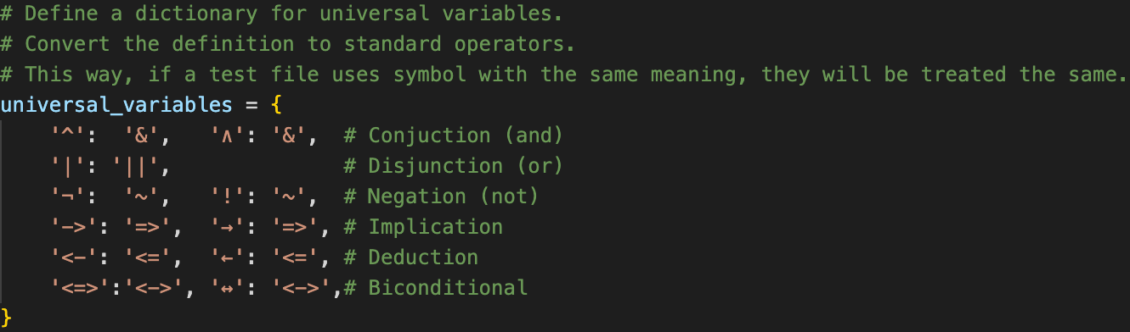**Deduction (<=)**: <-, ←.

Figure. Universal variables dictionary.

* **Biconditional (<->)**: <=>, ↔.

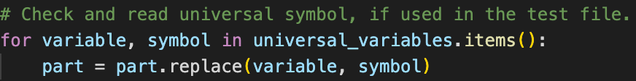To do this, we define a dictionary variable named universial_variables, which store a set of items defining an extended operator to the standard (universial) one.

Figure. Method replacing extended operator to the standard one.

Then, we use the method above to identify any ‘variable’ (extended operator used) in the test case, therefore, replace them to the ‘symbol’ (universial operator) one.

**Important Notice:** While the research section uses ‘<=>’ operator as the standard connective symbol for conditional setting, we utilise ‘<->’ instead to avoid code mismatching between them with the ‘=>’ and ‘<=’ symbols, therefore, enhance code accuracy. To do this, we will set ‘<->’ as the default meaning so all ‘<=>’ symbols will then be automatically converted to ‘<->’ for conditional checking.

# **D. Inference Methods**

## **1. Truth Table (TT)**

**Overview:**

The Truth Table method is a complete and exhaustive approach for determining the entailment of a query from a knowledge base (KB). This method evaluates all possible truth assignments for the propositional symbols involved, ensuring that the solution considers every potential scenario. It works with any type of KB (either Horn-form or generic cases).

**Process:**

Identify symbols: Extract all unique propositional symbols from the KB and query.

Generate Truth Assignments: Create a truth table that includes every possible combination of truth values (True or False) for these symbols. For 𝑛 symbols, there will be *2^n* rows in the truth table.

Evaluate KB and query: For each row in the truth table, evaluate the truth value of the entire KB by checking the truth value of each clause. A clause is satisfied if its premises imply its conclusion.

Check Entailment: Determine if the query is true in all models (rows) where the KB is true. If the query is true in every such model, then the KB entails the query.

**Example:**

KB: p→q.

Truth assignments: (p,q) can be (True,True), (True,False), (False,True), (False,False).

Evaluate each assignment:

(𝑇𝑟𝑢𝑒,𝑇𝑟𝑢𝑒): 𝑝→𝑞 is True

(𝑇𝑟𝑢𝑒,𝐹𝑎𝑙𝑠𝑒): 𝑝→𝑞 is False

(𝐹𝑎𝑙𝑠𝑒,𝑇𝑟𝑢𝑒): 𝑝→𝑞 is True

(𝐹𝑎𝑙𝑠𝑒,𝐹𝑎𝑙𝑠𝑒): 𝑝→𝑞 is True

If 𝑞 is true in all cases where the KB is true, the query is entailed.

**Advantages:**

Comprehensive since evaluating all possible scenarios, guaranteeing accuracy.

* Applicable to all KB test cases.

**Disadvantages:**

The number of truth assignments may extend exponentially, making it computationally intensive for large KB.

## **2. Forward Chaining (FC)**

**Overview:**

Forward Chaining is an efficient algorithm for Horn-form KBs, where each clause has at most one positive literal. It begins with known facts and applies inference rules to derive new facts until the query is proven or no more inferences can be made. This method is data-driven and operates in a forward direction from known facts to conclusions. This method utilises a pretty similar approach with Breadth-first Search algorithm from Assignment 1.

**Process:**

Initialize: Start with a set of known facts.

Apply Rules: Iteratively apply the inference rules. For each rule, if all premises (conditions) are known to be true, infer the conclusion and add it to the set of known facts.

Check Query: After each inference, check if the query is among the known facts. If it is, the query is entailed by the KB.

Repeat: Continue applying rules until no new facts can be derived.

**Example:**

KB: p2→p3; p3→p1; c→e; b&e→f; f&g→h; p2&p1&p3→d; p1&p3→c; a; b; p2.

Start with facts (single node without connectives): a, b, p2

Infer new facts using rules:

p2→p3: infer p3

p3→p1: infer p1

p1&p3→c: infer c

c→e: infer e

b&e→f: infer f

p2&p1&p3→d: infer d

Since d is inferred, the query is entailed.

**Advantages:**

Process rules linearly to derives conclusion quickly.

**Disadvantages:**

Only applicable to Horn-form KB test cases.

May infer irrelevant facts, hence becoming inefficient.

## **3. Backward Chaining (BC)**

**Overview:**

Backward Chaining is a goal-driven algorithm primarily used for Horn-form KBs. It starts with the query and attempts to prove it by recursively proving the sub-goals (premises) of the inference rules. This method works backward from the goal to known facts. This method utilises a pretty similar approach with Depth-first Search algorithm from Assignment 1.

**Process:**

Initialize: Start with the query as the goal.

Find Rules: Identify rules that conclude the current goal. For each rule, the goal can be concluded if all premises are true.

Prove Premises: Recursively attempt to prove each premise of the rule. If all premises of any rule can be proven, the goal is proven.

Check Facts: If a premise is a known fact, it is already proven. If not, find rules that can infer the premise and recursively prove them.

Repeat: Continue until the goal (query) is proven or all possible rules are exhausted.

**Example:**

KB: p2→p3; p3→p1; c→e; b&e→f; f&g→h; p2&p1&p3→d; p1&p3→c; a; b; p2.

Query: d

To prove d, find rules with d as the conclusion: p2&p1&p3→d

Prove p2&p1&p3:

p2: fact

p3: prove by p2->p3. p2 is fact, hence p3 is proven.

p1: prove by p3->p1. p3 is proven, so p1 is proven.

All premises of p2&p1&p3→d are proven; therefore, d is proven.

**Advantages:**

Efficiently targets the query and avoids irrelevant inferences.

Optimally handles cases with a single positive literal.

**Disadvantages:**

Only applicable to Horn-form KB test cases.

Can be inefficient if the recursion depth is high or if there are many interdependent goals.

# **E. Implementation**

The project is divided into 2 python files serving different functionalities inference.py and sequence.py. Both file will only need 1 terminal console input command line as instruction to trigger.

## **1. Main Script (inference.py)**

The main script handles the command-line interface, reads the input file, and calls the appropriate inference method, then executing result.

### a. Truth Table Parsing (table_reader)

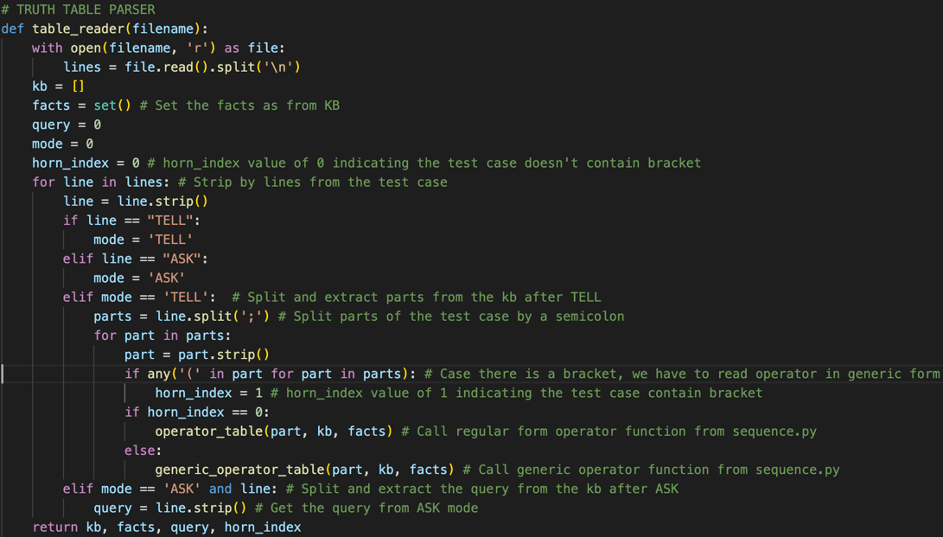**Purpose:** The **table_reader** function processes the KB and query from the file. This function will also distinguish and specialise method to execute functions with either a bracket (let’s call it generic) and without it (regular).

Figure. Code showing the table_reader function.

**Explanation**:

* + def table_reader(filename): Defines the function.
  + with open(filename, 'r') as file: Opens the file for reading.
  + lines = file.read().split('\n'): Reads the file content and splits it into lines.
* kb = {}: Initializes an empty dictionary to store the KB.
* facts = set(): Initializes an empty set to store known facts.
* query = 0: Initializes the query variable.
* mode = 0: Initializes the mode variable, which will determine if the current line is part of the KB or the query.
* horn_index = 0: Initialise this numeric variable to be 0 as default. When equal 0, it run the program for operator function with no bracket rule applied, while to be 1 trigger regular operator function.
* for line in lines: Iterates over each line in the file.
* line = line.strip(): Removes any leading or trailing whitespace from the line.
* if line == "TELL": If the line is "TELL", set the mode to 'TELL'.
* elif line == "ASK": Else if the line is "ASK", set the mode to 'ASK'.

For TELL mode:

* parts = line.split(';'): Split the line by semicolons into parts.
* for part in parts: Iterate over each part.
* part = part.strip(): Strip leading/trailing whitespace from the part.
* if any( '(' in part for part in parts): Check for any opening bracket from any part of parts, if there are, horn_index will be switch to 1.
* Case regular (no bracket) mode:
* operator_table(part, method, kb): Call the operator_table function to process the part and update the KB and facts for regular TT function.
* Case generic (have bracket) mode:
* generic_operator_table(part, method, kb): Call the generic_operator_table function to process the part and update the KB and facts for generic TT function.

For ASK mode:

* query = line.strip(): Set the query to the stripped line.
* return kb, facts, query, horn_index: Return the kb dictionary, facts set, query, horn_index afterwards.

**b. Generate a Truth Table (generate_truth_table)

Figure. Code showing the generate_truth_table function.

**Purpose:** This function generates a truth table for a given set of symbols.

**Explanation:**

* num_symbols = len(symbols): Get the total number of symbols in the set.
* table = []: Initialize an empty list to store the truth table.
* for bits in product([True, False], repeat=num_symbols): Generate all combinations of True/False for the symbols.
* table.append(dict(zip(symbols, bits))): Create a dictionary mapping each symbol to a truth value and append it to the table.
* return table: Return the generated truth table.

### c. Regular Truth Table Execution (truth_table)

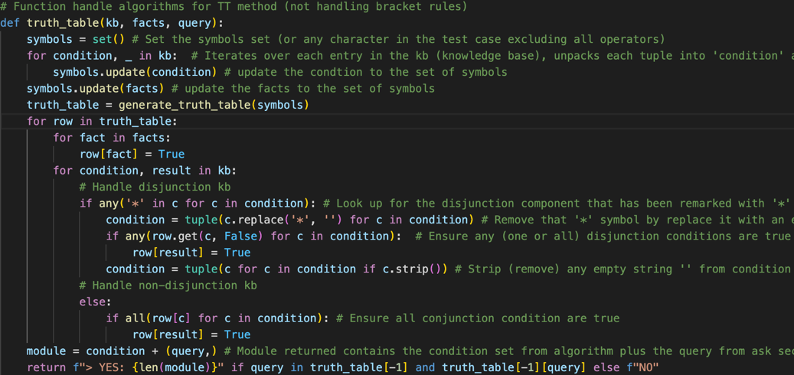**Purpose:** This function evaluates the knowledge base using the truth table method.

Figure. Code showing the truth_table function.

**Explanation:**

* symbols = set(): Initialize an empty set for the symbols.
* for condition, _ in kb: Iterate over each entry in the knowledge base.
* symbols.update(condition): Add the condition symbols to the symbols set.
* symbols.update(facts): Add the facts to the symbols set..
* truth_table = generate_truth_table(symbols): Generate the truth table.
* for row in truth_table: Iterate over each row in the truth table
* for fact in facts: row[fact] = True: Set the truth value of each fact to True.
* for condition, result in kb: Iterate over each condition-result pair in the knowledge base.
* if any('*' in c for c in condition): Check for disjunction (OR) in the condition, specified by *.
* condition = tuple(c.replace('*', '') for c in condition): Remove the '*' symbol from the condition.
* if any(row.get(c, False) for c in condition): If any condition is True.
* row[result] = True: Set the result to True in those case.
* condition = tuple(c for c in condition if c.strip()): Remove empty strings from the condition.

For conjunction (AND) in the condition.

* if all(row[c] for c in condition): If all conditions are True.
* row[result] = True: Set the result to True in those case.
* module = condition + (query,): Create a module with the condition and query.
* return f"> YES: {len(module)}" if query in truth_table[-1] and truth_table[-1][query] else f"NO": Return the result, indicating whether the query is entailed, with the module length.

### d. Generic Truth Table Execution – with bracket rules (generic_truth_table, evaluate_condition)

**d1. evaluate_condition**

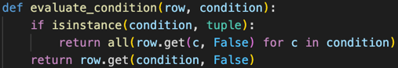**Purpose:** This function evaluates a condition based on a row in the truth table for the generic_truth_table function.

Figure. Code showing the evaluate_condition function.

**Explanation:**

* if isinstance(condition, tuple): Check if the condition is a tuple.
* return all(row.get(c, False) for c in condition): Evaluate each condition in the row and return True if all are True.
* return row.get(condition, False): Return the value of the condition in the row, defaulting to False if not found.

**d2. generic_truth_table**

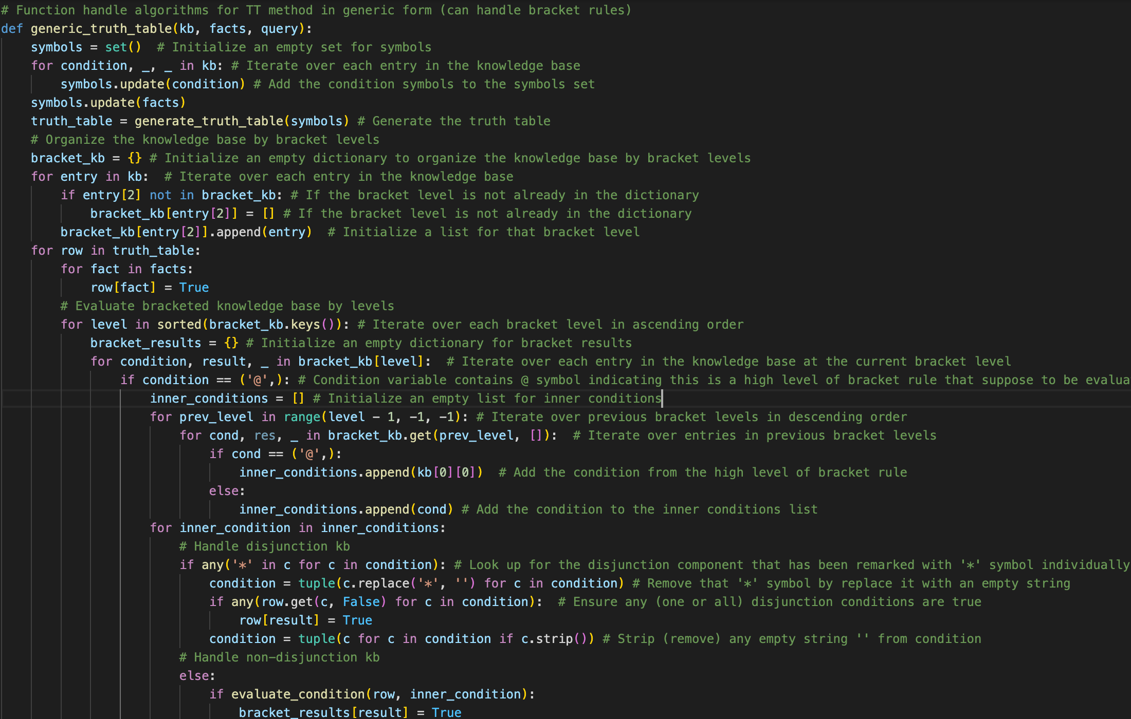**Purpose:** This function evaluates the knowledge base using the Truth Table (TT) method in a generic form, handling bracket rules.

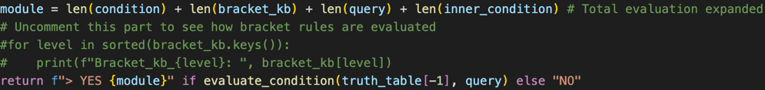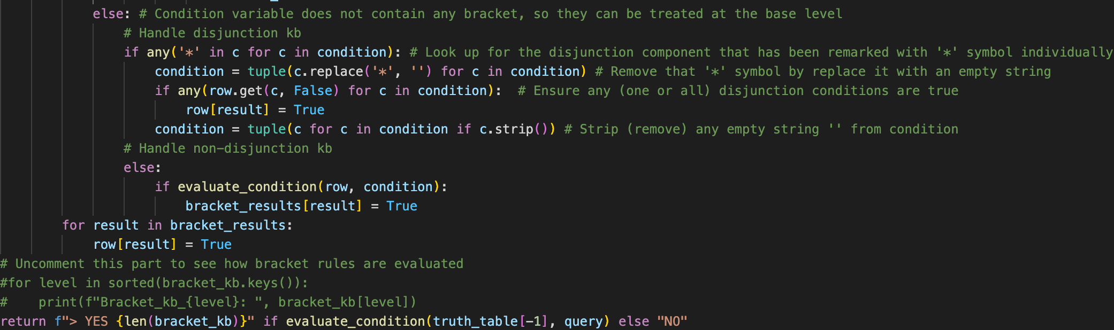**Explanation:**

Figures. Code showing the generic_truth_table function.

* symbols = set(): Initialize an empty set for symbols
* for condition, _, _ in kb: Iterate over each entry in the knowledge base
* symbols.update(condition): Add the condition symbols to the symbols set
* symbols.update(facts): Add the facts to the symbols set
* truth_table = generate_truth_table(symbols): Generate the truth table
* bracket_kb = {}: Initialize an empty dictionary to organize the knowledge base by bracket levels
* for entry in kb: Iterate over each entry in the knowledge base
* if entry[2] not in bracket_kb: If the bracket level is not in the dictionary (index 2 from entry)
* bracket_kb[entry[2]] = [] Initialize a list for that bracket level
* bracket_kb[entry[2]].append(entry) Append the entry to the list for the respective bracket level
* for row in truth_table: Iterate over each row in the truth table
* for fact in facts: row[fact] = True: Set the truth value of each fact to True
* for level in sorted(bracket_kb.keys()): Iterate over each bracket level in ascending order
* bracket_results = {}: Initialize an empty dictionary for bracket results
* for condition, result, _ in bracket_kb[level]: Iterate over each entry in the knowledge base at the current bracket level
* if condition == ('@',): If condition indicates a high level of bracket rule (with @ symbol)
* inner_conditions = []: Initialize an empty list for inner conditions
* for prev_level in range(level - 1, -1, -1): Iterate over previous level in descending order
* for cond, res, _ in bracket_kb.get(prev_level, []): Iterate over entries in previous levels
* if cond == ('@',): inner_conditions.append(kb[0][0]): Add the condition from the high level of bracket rule
* else: inner_conditions.append(cond): Add the condition to the inner conditions list
* for inner_condition in inner_conditions: Iterate over each inner condition

Handle disjunction and non-disjunction kb with inner conditions of the bracket rule:

# Handle disjunction kb

* if any('*' in c for c in condition): Look up for the disjunction component that has been remarked with '*' symbol individually
* condition = tuple(c.replace('*', '') for c in condition): Remove that '*' symbol
* if any(row.get(c, False) for c in condition): Ensure any disjunction conditions are true
* condition = tuple(c for c in condition if c.strip()): Remove any empty string

# Handle non-disjunction kb

* if evaluate_condition(row, inner_condition): If inner_condition is true
* bracket_results[result] = True: Set the bracket result to true

Handle disjunction and non-disjunction knowledge base with regular conditions:

* This will be the same approach as the bracket condition one, only that we set the condition explicitly instead of the inner_condition (as they don’t have it).
* We have to return inner_condition variable as empty for this scenario.
* module = len(condition) + len(bracket_kb) + len(query) + len(inner_condition): Set the module expanded as the total number of condition and inner_condition, query and bracket_kb.
* return f"> YES {module}" if evaluate_condition(truth_table[-1], query) else "NO": Return "YES" with the length of the bracket knowledge base if the query is True in the last row of the truth table, otherwise return "NO"

### e. Forward and Backward Chain Parsing (chain_reader)

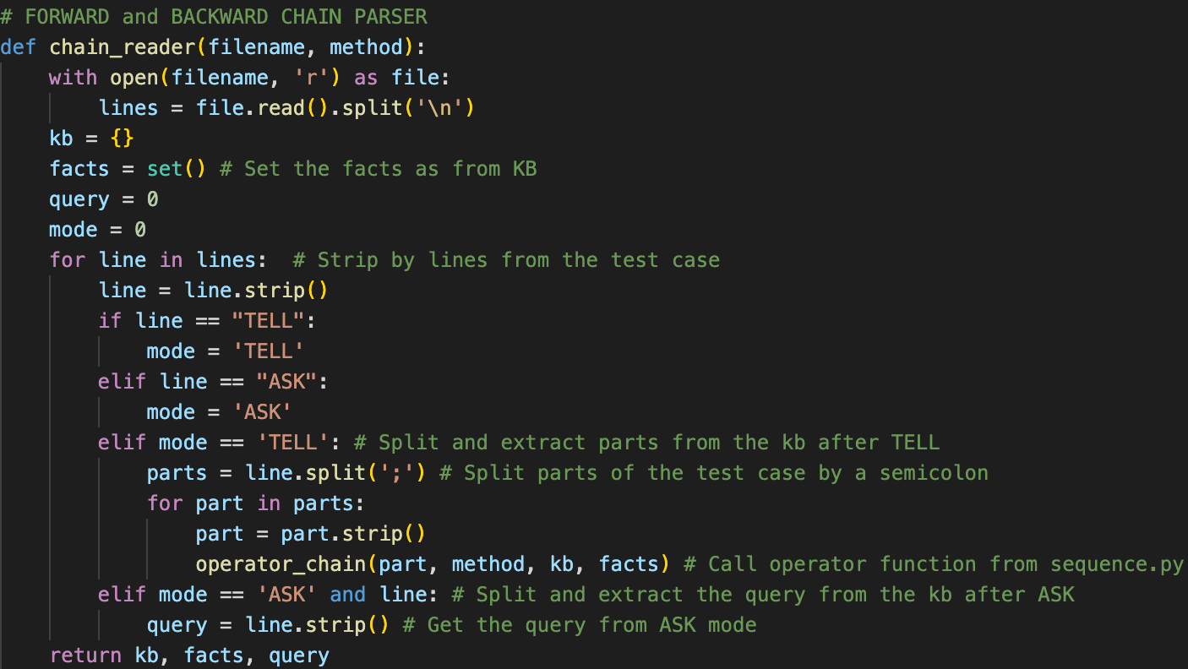**Purpose:** This function reads a knowledge base (KB) from a file and processes it for Forward Chaining (FC) or Backward Chaining (BC).

Figure. Code showing the chain_reader function.

**Explanation**:

* + def chain_reader(filename, method): Defines the function, taking a filename and a method (either 'FC' or 'BC') as input.
  + with open(filename, 'r') as file: Opens the file for reading.
  + lines = file.read().split('\n'): Reads the file content and splits it into lines.
* kb = {}: Initializes an empty dictionary to store the KB.
* facts = set(): Initializes an empty set to store known facts.
* query = 0: Initializes the query variable.
* mode = 0: Initializes the mode variable, which will determine if the current line is part of the KB or the query.
* for line in lines: Iterates over each line in the file.
* line = line.strip(): Removes any leading or trailing whitespace from the line.
* if line == "TELL": If the line is "TELL", set the mode to 'TELL'.
* elif line == "ASK": Else if the line is "ASK", set the mode to 'ASK'.

For TELL mode:

* parts = line.split(';'): Split the line by semicolons into parts.
* for part in parts: Iterate over each part.
* part = part.strip(): Strip leading/trailing whitespace from the part.
* operator_chain(part, method, kb, facts): Call the operator_chain function to process the part and update the KB and facts.

For ASK mode:

* query = line.strip(): Set the query to the stripped line.
* return kb, facts, query: Return the KB dictionary, facts set, and query afterwards.

### f. Forward Chain Execution (forward_chain)

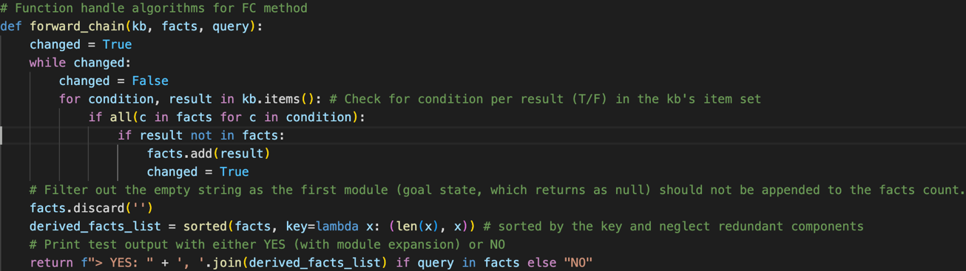**Purpose**: Implement the Forward Chaining algorithm to derive new facts and determine if the query can be inferred.

Figure. Code showing the forward_chain function.

**Explanation**:

* + def forward_chain(kb, facts, query): Defines the function, taking the KB, facts set, and query as input.
* changed = True: Initialize changed to True to enter the loop.
* while changed: Loop until no new facts are derived.
* changed = False: Reset changed to False at the start of each iteration.
* for condition, result in kb.items(): Iterate over each condition-result pair in the KB.
* if all(c in facts for c in condition): Check if all parts of the condition are in the facts set.
* if result not in facts: If the result is not already in the facts set.
* facts.add(result): Add the result to the facts set.
* changed = True: Set changed to True to indicate that a new fact was derived.
* facts.discard(''): Remove any empty string from the facts set.
* derived_facts_list = sorted(facts, key=lambda x: (len(x), x)): Sort the derived facts.
* return f"> YES: " + ', '.join(derived_facts_list) if query in facts else "NO": Return the result, indicating whether the query is in the derived facts.

### g. Backward Chain Execution (backward_chain)

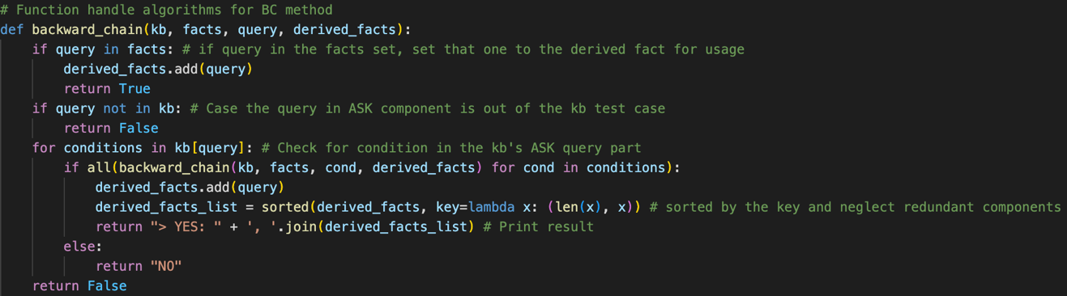**Purpose**: Implement the Forward Chaining algorithm to recursively prove the query.

Figure. Code showing the backward_chain function.

**Explanation**:

* def backward_chain(kb, facts, query, derived_facts): Defines the function, taking the KB, facts set, query, and derived facts set as input.
* if query in facts: If the query is in the facts set.
* derived_facts.add(query): Add the query to the derived facts set.
* return True: Return True to indicate that the query is proven.
* if query not in kb: If the query is not in the KB.
* return False: Return False to indicate that the query cannot be proven.
* for conditions in kb[query]: Iterate over each condition set for the query in the KB.
* if all(backward_chain(kb, facts, cond, derived_facts) for cond in conditions): Recursively check if all conditions can be proven.
* derived_facts.add(query): Add the query to the derived facts set.
* derived_facts_list = sorted(derived_facts, key=lambda x: (len(x), x)): Sort the derived facts.
* return "> YES: " + ', '.join(derived_facts_list): Return the result if the query is proven. Else, return “NO”.
* return False: Return False if the loop completes without proving the query.

### h. Main Operator

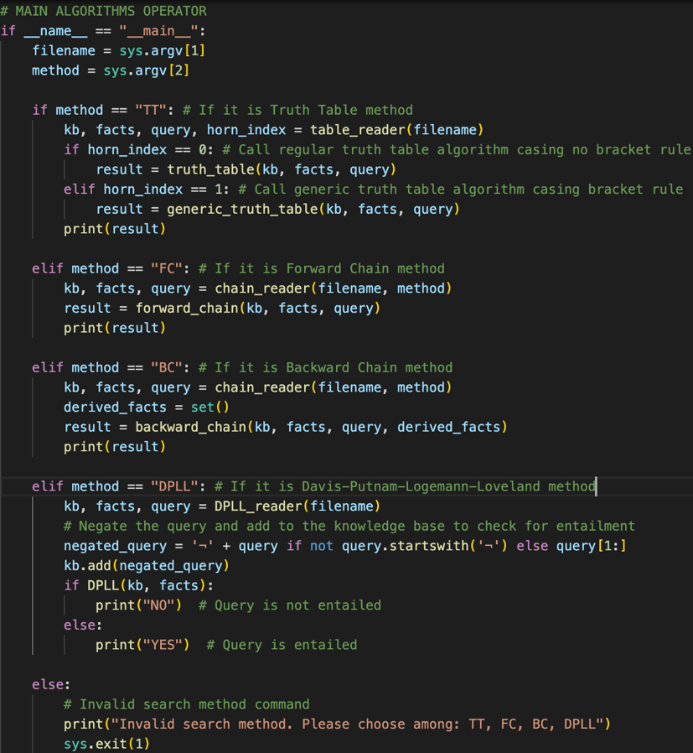This function will trigger the project, reading the desired KB file and perform method as request.

Figure. Code showing the main operator.

From the user’s terminal input command, the operator will get the filename from the first index [1] (KB test case to be used) and the desired method from the second index [2].

* If the method input is TT (Truth Table), it will get ‘kb’, ‘facts’, ‘query’ and ‘horn_index’ variables from table_reader function. Then, in case ‘horn_index’ is 0, implying the test case doesn’t contain any bracket, it set to set to the truth_table function, in order to obtain the final ‘result’ and print out, else, if ‘horn_index’ is 1 (indicating bracket rule applied), it call generic_truth_table function instead.
* If the method input is FC (Forward Chain), it will get ‘kb’, ‘facts’, and ‘query’ variables from chain_reader function, then set to the forward_chain function, in order to obtain the final ‘result’ and print out.
* If the method input is BC (Backward Chain), it will get ‘kb’, ‘facts’ and ‘query’ variables from chain_reader function, then set new variable ‘derived_facts’, before set all of these to the backward_chain function, in order to obtain the final ‘result’ and print out.
* If the method input is DPLL (Davis-Putnam-Logemann-Loveland), it will get ‘kb’, ‘facts’ and ‘query’ variables from DPLL_reader function, then negate the query with ‘¬’ symbol and add to the kb for entailment checking. The result will be printed as “YES” or “NO” from the method DPLL’s True or False result returned.
* Else if the method does not match any of those listed, it print error message and exit the loop.

## **2. Sequence Handling (sequence.py)**

This script contains the **operator_table,** **operator_chain**, and **generic_operator_table** functions to process logical operators (conditionals and connectives).

### a. Truth Table Operator Handler (operator_table)

**Purpose:** This function processes logical expressions (knowledge base entries) and updates the knowledge base (KB) and facts accordingly for the Truth Table (TT) method. It handles various logical operators such as implication (=>), deduction (<=), biconditional (<->), conjunction (&), disjunction (||), and negation (~).

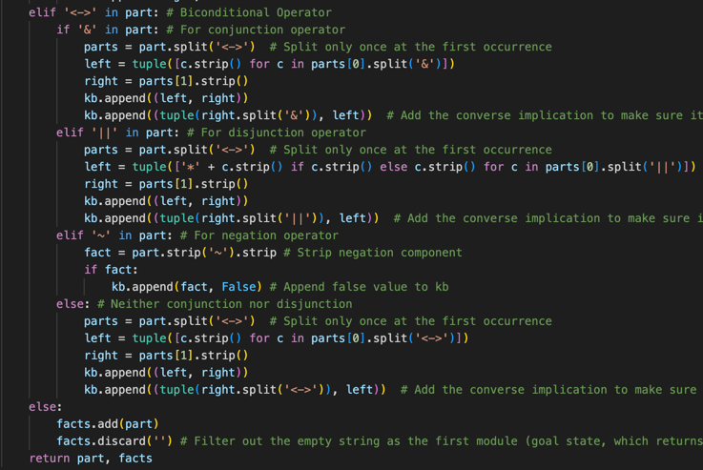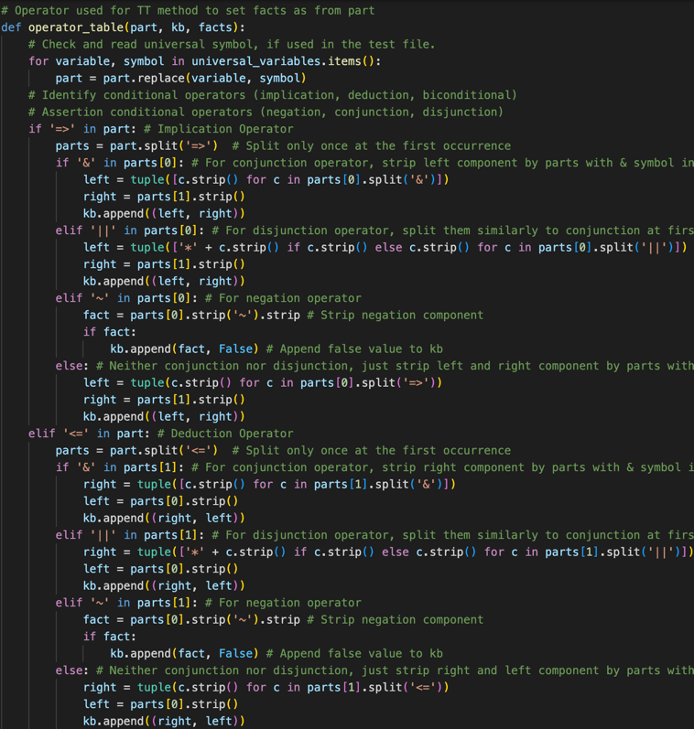**Explanation:**

Figures. Code showing the operator_table function.

def operator_table(part, kb, facts):

Defines the function operator_table which takes a part (a logical expression), kb (the knowledge base), and facts as input.

for variable, symbol in universal_variables.items():

part = part.replace(variable, symbol)

Replaces any universal symbols in the part based on a predefined dictionary universal_variables.

**a1. Handling Implication (=>)**

if '=>' in part:

parts = part.split('=>')

Checks if the implication operator (=>) is present in the part and splits the part into two components (left and right) at the first occurrence of =>.

Conjunction in Implication

if '&' in parts[0]:

left = tuple([c.strip() for c in parts[0].split('&')])

right = parts[1].strip()

kb.append((left, right))

If the left component contains a conjunction (&), it splits it into individual conditions, strips whitespace, and appends the tuple of conditions and the right component to the kb.

Disjunction in Implication

elif '||' in parts[0]:

left = tuple(['*' + c.strip() if c.strip() else c.strip() for c in parts[0].split('||')])

right = parts[1].strip()

kb.append((left, right))

If the left component contains a disjunction (||), it splits it into individual conditions, strips whitespace, marks them with a * symbol, and appends the tuple of conditions and the right component to the kb.

Negation in Implication

elif '~' in parts[0]:

fact = parts[0].strip('~').strip()

if fact:

kb.append((fact, False))

If the left component contains a negation (~), it strips the negation symbol and whitespace, and appends the fact with a False value to the kb.

Simple Implication (no connective)

else:

left = tuple(c.strip() for c in parts[0].split('=>'))

right = parts[1].strip()

kb.append((left, right))

If the left component does not contain conjunction, disjunction, or negation, it strips whitespace and appends the tuple of left and right components to the kb.

**a2. Handling Deduction (<=)**

elif '<=' in part:

parts = part.split('<=')

Checks if the deduction operator (<=) is present in the part and splits the part into two components (left and right) at the first occurrence of <=.

Conjunction in Deduction

if '&' in parts[1]:

right = tuple([c.strip() for c in parts[1].split('&')])

left = parts[0].strip()

kb.append((right, left))

If the right component contains a conjunction (&), it splits it into individual conditions, strips whitespace, and appends the tuple of conditions and the left component to the kb.

Disjunction in Deduction

elif '||' in parts[1]:

right = tuple(['*' + c.strip() if c.strip() else c.strip() for c in parts[1].split('||')])

left = parts[0].strip()

kb.append((right, left))

If the right component contains a disjunction (||), it splits it into individual conditions, strips whitespace, marks them with a * symbol, and appends the tuple of conditions and the left component to the kb.

Negation in Deduction

elif '~' in parts[1]:

fact = parts[0].strip('~').strip()

if fact:

kb.append((fact, False))

If the right component contains a negation (~), it strips the negation symbol and whitespace, and appends the fact with a False value to the kb.

Simple Deduction (no connective)

else:

right = tuple(c.strip() for c in parts[1].split('<='))

left = parts[0].strip()

kb.append((right, left))

If the right component does not contain conjunction, disjunction, or negation, it strips whitespace and appends the tuple of right and left components to the kb.

**a3. Handling Biconditional (<->)**

elif '<->' in part:

if '&' in part:

parts = part.split('<->')

Checks if the biconditional operator (<->) is present in the part and splits the part into two components (left and right) at the first occurrence of <->.

Conjunction in Biconditional

left = tuple([c.strip() for c in parts[0].split('&')])

right = parts[1].strip()

kb.append((left, right))

kb.append((tuple(right.split('&')), left))

If the part contains a conjunction (&), it splits it into individual conditions, strips whitespace, and appends the tuple of conditions and the right component to the kb. It also appends the converse implication to ensure the biconditional logic.

Disjunction in Biconditional

elif '||' in part:

parts = part.split('<->')

left = tuple(['*' + c.strip() if c.strip() else c.strip() for c in parts[0].split('||')])

right = parts[1].strip()

kb.append((left, right))

kb.append((tuple(right.split('||')), left))

If the part contains a disjunction (||), it splits it into individual conditions, strips whitespace, marks them with a * symbol, and appends the tuple of conditions and the right component to the kb. It also appends the converse implication to ensure the biconditional logic.

Negation in Biconditional

elif '~' in part:

fact = part.strip('~').strip()

if fact:

kb.append((fact, False))

If the part contains a negation (~), it strips the negation symbol and whitespace, and appends the fact with a False value to the kb.

Simple Biconditional

else:

parts = part.split('<->')

left = tuple([c.strip() for c in parts[0].split('<->')])

right = parts[1].strip()

kb.append((left, right))

kb.append((tuple(right.split('<->')), left))

If the part does not contain conjunction, disjunction, or negation, it strips whitespace and appends the tuple of left and right components to the kb. It also appends the converse implication to ensure the biconditional logic.

**a4. Handling Simple Facts (without conditional (=>, <=, <->) and connective (~, ||, &)**

else:

facts.add(part)

facts.discard(' ')

If the part does not contain any logical operators, it adds the singular part to the facts set and ensures that the empty string (‘ ‘) is not included in the facts.

return part, facts

Returns the part and the updated facts set.

### b. Forward and Backward Chaining Operator Handler (operator_chain)

**Purpose:** This function process a part of the KB and update the KB, or facts based on the method (FC or BC), while interpreting and defining conditional and connective operators detected.

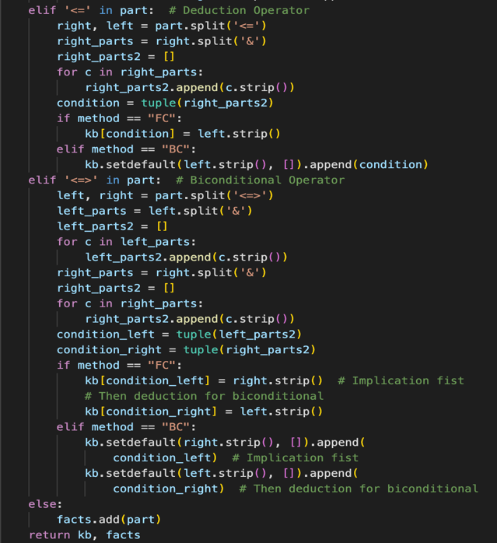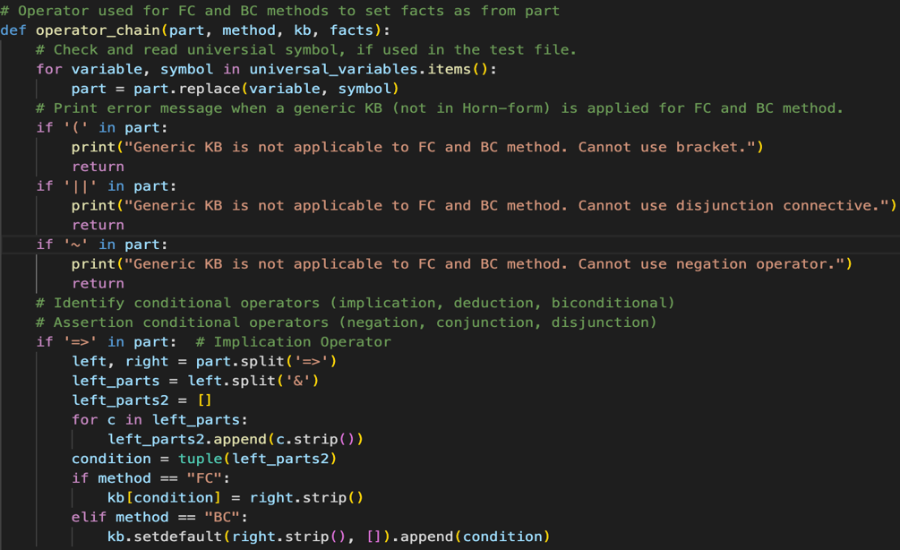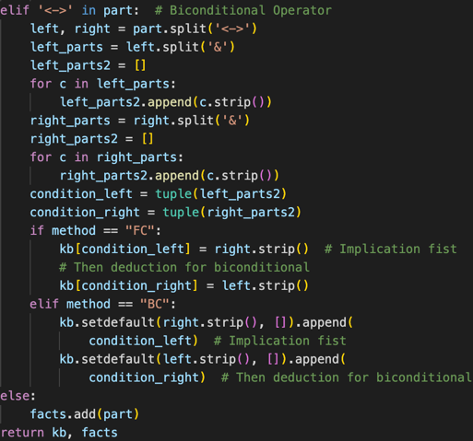**Explanation**:

Figures. Code showing the operator_chain function.

* def operator_chain(part, method, kb, facts): Defines the function, taking a part of the KB, method, KB dictionary, and facts set as input.
* If any of these conditions are true, print an error message and return without processing the part. FC and BC method can only being Horn-form, therefore, these operators are not applicable:
* if '(' in part: Check if the part contains brackets.
* if '||' in part: Check if the part contains disjunctions.
* if '~' in part: Check if the part contains negations.

Case implication (if '=>' in part):

* left, right = part.split('=>'): Split the part into left and right sides of the implication operator.
* left_parts = left.split('&'): Split the left side into individual conditions.
* left_parts2 = []: Initialize a list to hold stripped conditions.
* for c in left_parts: Iterate over each condition.
* left_parts2.append(c.strip()): Strip and add each condition to left_parts2.
* condition = tuple(left_parts2): Convert left_parts2 to a tuple.
* if method == "FC": If the method is FC, update the KB with the condition and right side.
* elif method == "BC": If the method is BC, update the KB with the right side and condition.

Case deduction (if '<=' in part):

* right, left = part.split('<='): Split the part into left and right sides of the deduction operator.
* The rest of the processing is similar to implications but with the roles of left and right sides reversed.

Case biconditional (if '<->' in part):

* left, right = part.split('<->'): Split the part into left and right sides of the biconditional operator.
* Biconditional operator handler utilise the ‘implicate then deduct’ approach, by which it combine the method obtaining the left and right part similarly from both implication and deduction cases.
* Therefore, the biconditional processing is similar to implications and deductions but involves both directions (left to right and right to left).

If there are no connective conditional operator (=>, <= or <->):

* facts.add(part): Add the standalone part to the facts set.
* return kb, facts: Return the updated KB and facts eventually.

### c. Truth Table Operator Handler with Bracket Rule applied (generic_operator_table)

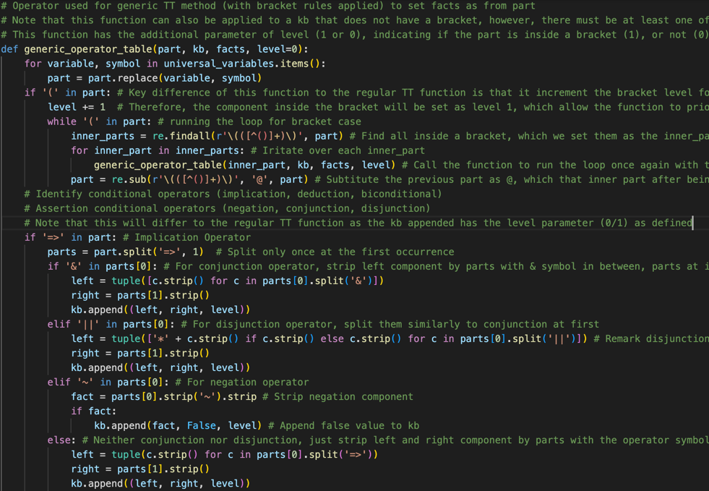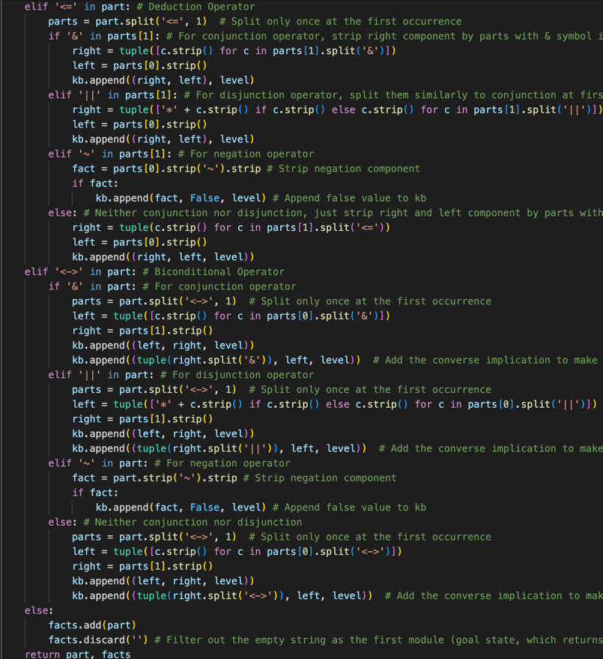**Purpose:** This function processes logical expressions (knowledge base entries), updates KB and facts accordingly for the Truth Table (TT) method, alongside with applying bracket rule. Notice that this function can also handle the KB that not within a bracket but make sure at least 1 KB from that test case must have the bracket to ensure seamless operation.

Figures. Code showing the generic_operator_table function.

**Explanation:**

Basically, this function will be similar to the regular TT method, only 2 noticeable logical application has been implemented in addition:

def generic_operator_table(part, kb, facts, level=0): Firstly, this function has the additional parameter of level (1 or 0), indicating if the part is inside a bracket (1), or not (0), which is different to **operator_table**.

**c1. Applying bracket level evaluation**

* if '(' in part: For each opening bracket ‘(‘ detected
* level += 1: The component inside the bracket will be set as level 1, which allow the function to prioritise handling parts without the bracket first
* while '(' in part: running the loop for bracket case
* inner_parts = re.findall(r'\(([^()]+)\)', part): Find all inside a bracket, set as ‘inner_parts’.
* for inner_part in inner_parts: Irritate over each inner_part
* generic_operator_table(inner_part, kb, facts, level): Call the function to run the loop once again with the inner_part extracted, while we have append the level to be 1
* part = re.sub(r'\(([^()]+)\)', '@', part): Substitute the previous part as @, which that inner part after being evaluated (T/F), will set @ character's value to be T/F.

**c2. KB appended return with an extra parameter of the bracket level**

After we apply the bracket rule with level evaluation, each time we append the knowledge base by ‘kb.append’, we have to set them with 3 parameters, including ‘level’ additionally, hence, ‘kb’ returned will be set with that indicated level (0 or 1) to allow the **generic_truth_table** function run properly.

# **F. Testing**

The engine was tested with various KBs to ensure correctness. Specific test cases were designed to cover different logical constructs and complex scenarios.

Below are 16 test cases, labelled accordingly to their testing features and include 3 given example cases.

And 2 test cases for DPLL method:

Figure. Table of 2 DPLL test cases’ result.

Figures. 16 (+3) tables showing different test cases with their results applying the 3 methods.

# **G. Features/Bugs/Missing**

## **1. Features**

* Comprehensive Truth Table evaluation with 2 distinguished features, regular mode for the test case KB without a bracket and generic mode for the test case KB with bracket rule applied.
* Bracket rule evaluation will be based on the bracket level, to allow all ‘kb’ to be evaluated with a correct sequence.
* Truth Table can accurately determine if the query is entailed with a vast set of generic-operators and bracket by distinguish and evaluate them separately with appropriate logics.
* Efficient Forward Chaining for Horn-form clauses.
* Recursive Backward Chaining for goal-driven inference with Horn-form.
* Determine entailment of the query using Davis-Putnam-Logemann-Loveland (DPLL) method.
* Supports a wide range of logical operators, and connectives (with extended operators dictionary).

## **2. Bugs**

Generic mode (bracket rule applied) must be ensured that the test case must have at least 1 ‘kb’ that has a bracket (or more), else if a non-bracket test case run this program, error will be printed out. Yet, notice that the **table_reader** and main **operator** has already accurately distinguish and assigning the mode accurately, so this is just a friendly reminder to the user.

Similarly, Forward and Backward Chaining method programs can only handle Horn-form (plus deduction and biconditional) so it cannot handle generic form.

Bracket evaluation can return mismatching in module expanded for a very complex test case.

DPLL method for research section must be tested with DPLL-formatted test case, any test cases that are not properly formatted may return errors.

## **3. Missing Features**

Extended research algorithms resolution-based theorem prover algorithm is not applied in this project due to timeliness concerning.

DPLL formatted test case should have an additional method to be distinguished and avoid errors.

DPLL method can only determine YES or NO responding to whether the query is entailed.

# **H. Research (Operator components and DPLL algorithm)**

Research components applied in this project including methods to handle additional conditional and connective operators such as Disjunction (||), Negation (~), Biconditional (<=>) and bracket rules. Notice that all of these features are non-Horn-form so they can only be applied to Truth Table. Here’s a brief explanation of how each of these works within the project:

**Disjunction (||)**

* + Deduction: When a disjunction (||) is encountered in an implication (=>) or deduction (<=) expression, the left or right component (depending on the context) is split into individual conditions. These conditions are marked with a '*' symbol to indicate disjunction.
  + Truth Table Evaluation: During the truth table evaluation, if any condition marked with '*' is true, the result is set to true (which by different to Conjunction that would check for all condition).

**Negation (~)**

* + Handling Negation: When a negation (~) is encountered, the component following the ''symbol is stripped of the negation symbol and appended to the knowledge base (KB) with a False value. This indicates that the fact is not true.

**Biconditional (<=>)**

* + Handling Biconditional: The biconditional operator (<=>) signifies that both sides of the expression imply each other. The expression is split into left and right components. Each component is processed to handle conjunctions and disjunctions, and the converse implication is also added to the KB to ensure the biconditional logic is respected.

**Bracket Rules**

* + Handling Brackets: Bracket rules are used to prioritize certain logical expressions. When brackets are detected, the expression inside the brackets is processed first. This involves recursively evaluating inner expressions and substituting them with a special character ('@') to denote their evaluated result.
  + Bracket Levels: Each knowledge base entry is tagged with a bracket level to ensure correct processing order during truth table evaluation. Entries without brackets are processed first, followed by entries with brackets, ensuring the correct application of logical precedence.

Next, we have the research algorithm of Davis-Putnam-Logemann-Loveland (DPLL). In brief, The DPLL algorithm is a method used to determine the satisfiability of propositional logic formulas, particularly in conjunctive normal form (CNF). It works by systematically exploring truth assignments for variables, employing techniques like unit propagation and backtracking.

**a. DPLL_reader:**

**Purpose:**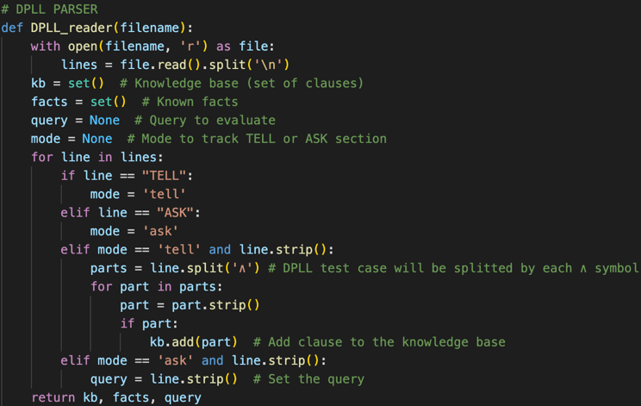The DPLL_reader function reads and parses an input file to extract the knowledge base (KB) and the query for the DPLL algorithm. The file is expected to contain a TELL section with clauses and an ASK section with a query.

Figures. Code showing the DPLL_reader function.

**Explanation:**

Started with similar approach by identify mode and read the text file like other methods.

parts = line.split('∧'): Splits the line into parts by the '∧' symbol.

for part in parts: Iterates through each part.

part = part.strip(): Strips whitespace from the part.

if part: kb.add(part): If the part is non-empty, adds the part to the knowledge base.

query = line.strip(): Sets the query.

return kb, facts, query: Returns the knowledge base, facts, and query.

**b. evaluate_clause:**

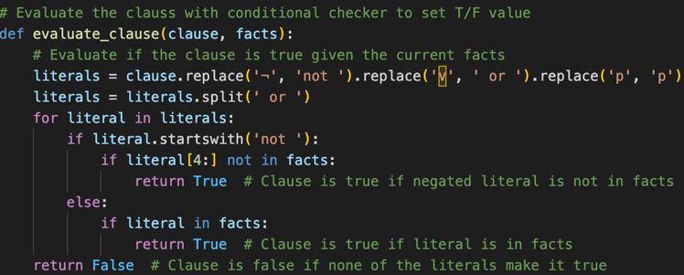**Purpose:** The function checks if a given clause is satisfied based on the current set of facts.

Figures. Code showing the evaluate_clause function.

**Explanation:**

literals = clause.replace('¬', 'not ').replace('∨', ' or ').replace('p', 'p'): Transforms the clause into a format that can be evaluated by replacing '¬' with 'not' and '∨' with 'or'.

literals = literals.split(' or '): Splits the transformed clause into individual literals.

for literal in literals: Iterates through each literal.

if literal.startswith('not '): Checks if the literal is negated.

if literal[4:] not in facts: return True: Returns True if the negated literal is not in the facts.

else: if literal in facts: Else (if the literal is not negated), checks if the literal is in the facts.

return True: Returns True if the literal is in the facts.

return False: Returns False if none of the literals make the clause true.

**c. DPLL:**

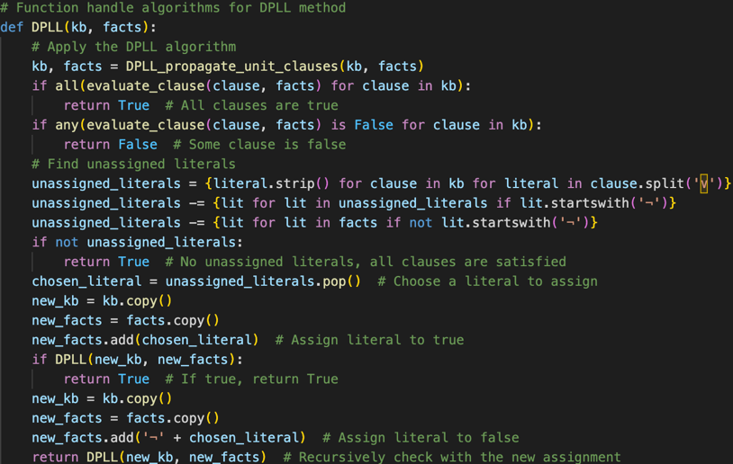**Purpose:** The DPLL function implements the Davis-Putnam-Logemann-Loveland (DPLL) algorithm to check the satisfiability of a set of clauses.

Figures. Code showing the DPLL function.

**Explanation:**

kb, facts = DPLL_propagate_unit_clauses(kb, facts): Propagates unit clauses to simplify the knowledge base.

if all(evaluate_clause(clause, facts) for clause in kb): Checks if all clauses are true.

return True: Returns True if all clauses are true.

if any(evaluate_clause(clause, facts) is False for clause in kb): Checks if any clause is false.

return False: Returns False if any clause is false.

unassigned_literals = {literal.strip() for clause in kb for literal in clause.split('∨')}: Finds every unassigned literals.

unassigned_literals -= {lit for lit in unassigned_literals if lit.startswith('¬')}: Removes negated literals from the set of unassigned literals.

unassigned_literals -= {lit for lit in facts if not lit.startswith('¬')}: Removes literals already assigned.

if not unassigned_literals: return True: Checks if there are no unassigned literals, returns True.

chosen_literal = unassigned_literals.pop(): Chooses a literal to assign.

new_kb = kb.copy(): Copies the knowledge base.

new_facts = facts.copy(): Copies the facts.

new_facts.add(chosen_literal): Assigns the chosen literal to true.

if DPLL(new_kb, new_facts): return True: Recursively applies the DPLL algorithm and return True

new_kb = kb.copy(): Copies the knowledge base again.

new_facts = facts.copy(): Copies the facts again.

new_facts.add('¬' + chosen_literal): Assigns the negation of the chosen literal to false.

return DPLL(new_kb, new_facts): Recursively checks with the new assignment.

**d. DPLL_propagate_unit_clauses (from Sequence.py):**

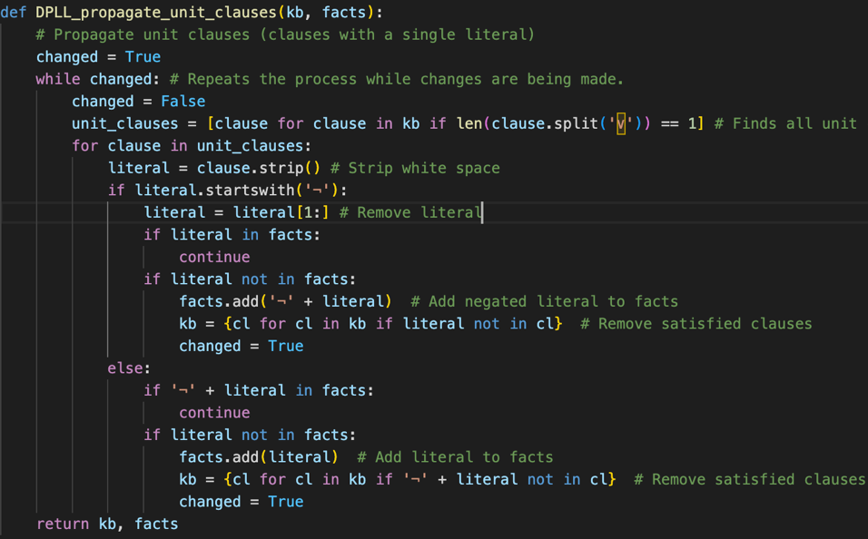**Purpose:** The DPLL_propagate_unit_clauses function simplifies the knowledge base by propagating unit clauses (clauses with a single literal).

Figures. Code showing the DPLL_propagate_unit_clauses function.

**Explanation:**

changed = True: Initializes the changed flag to True.

while changed: Repeats the process while changes are being made.

changed = False: Resets the changed flag.

unit_clauses = [clause for clause in kb if len(clause.split('∨')) == 1]: Finds all unit clauses.

for clause in unit_clauses: Iterates through each unit clause.

literal = clause.strip(): Strips whitespace from the clause.

if literal.startswith('¬'): Checks if the literal is negated.

literal = literal[1:]: Removes the negation from index 1.

if literal in facts: continue: Skips to the next iteration if the literal is already in the facts.

if literal not in facts: Checks if the literal is not in the facts.

facts.add('¬' + literal): Adds the negated literal to the facts.

kb = {cl for cl in kb if literal not in cl}: Removes satisfied clauses from the knowledge base.

changed = True: Sets the changed flag to True.

else: If the literal is not negated.

if '¬' + literal in facts: continue: Skip to the next iteration if the negated literal is already in the facts.

if literal not in facts: Checks if the literal is not in the facts.

facts.add(literal): Adds the literal to the facts.

kb = {cl for cl in kb if '¬' + literal not in cl}: Removes satisfied clauses from the knowledge base.

changed = True: Sets the changed flag to True.

return kb, facts: Returns the updated knowledge base and facts.

# **I. Team Summary Report**

Each team member contributed to different aspects of the project, including coding, testing, and documentation. Regular meetings ensured smooth collaboration and integration of individual contributions.

Task Division with specified task components completed by each member

**Dang Khoa Le (103844421)**

Function:table_reader, chain_reader, truth_table, backward_chain, operator_table, operator_chain, generic_truth_table, generic_operator_table, Main operator, DPLL_reader, DPLL, evaluate_clause, DPLL_propagate_unit_clauses.

Feature: Parse data to the desired functions; Disjunction, Reduction, Biconditional, Bracket rules, Truth Table, Backward Chain, Table, Generic Table and Chain Operator, DPLL algorithms, Testing, Report Writing.

**Saw Ko Ko Oo (104150310):**

Function:table_reader, chain_reader, truth_table, generate_truth_table, forward_chain, backward_chain, operator_table, operator_chain, DPLL_reader, DPLL, evaluate_clause, DPLL_propagate_unit_clauses.

Feature: Parse data from text file; Conjunction, Negation, Implication, Truth Table, Forward Chain, Backward Chain, Table and Chain Operator, DPLL algorithms, Testing.

# **J. Conclusion**

The implementation of the Propositional Logic Inference Engine showcases the versatility and effectiveness of various inference algorithms, including Truth Table (TT) checking, Forward Chaining (FC), Backward Chaining (BC), and the Davis-Putnam-Logemann-Loveland (DPLL) method. Each algorithm offers unique advantages tailored to different knowledge base (KB) structures, providing a comprehensive toolkit for logical inference in artificial intelligence.

# **K. Acknowledgements/Resources**

We acknowledge the assistance of our course instructors and the following resources:

* "Artificial Intelligence: A Modern Approach" by Stuart Russell and Peter Norvig: Research insight to the AI context with strategic approach.
* “Python Documentation: Data Structures and Algorithms in Python”: Provide understanding in regards with python methods.
* “Expert Systems: How to implement a backward chaining resolver in Python” by Jean-Baptiste Terrazzoni: Utilisation of FC and BC by Python.
* “Truth Table Generator” by Keith Schwarz from Stanford University: Provide reference on how truth table are evaluated using JavaScript.
* “How does DPLL Algorithm Work? A Brief Explanation of DPLL” by Mert Özlütıraş: Understand how DPLL algorithms is defined.

# **L. References**

* Russell, S., & Norvig, P. (2021). Artificial Intelligence: A Modern Approach (4th ed.). Pearson.
* Python Documentation (3.12.3). Data Structures and Algorithms in Python. Retrieved from: <https://docs.python.org/3/tutorial/datastructures.html>
* Jean-Baptiste Terrazzoni (2019). Expert Systems: How to implement a backward chaining resolver in Python. Retrieved from: <https://medium.com/a-42-journey/expert-systems-how-to-implement-a-backward-chaining-resolver-in-python-bf7d8924f72f>
* Keith Schwarz from Stanford University. Truth Table Generator. Retrieved from <https://web.stanford.edu/class/cs103/tools/truth-table-tool/>
* Mert Özlütıraş (2021). How does DPLL Algorithm Work? A Brief Explanation of DPLL. Retrieved from: <https://mertozlutiras.medium.com/brief-explanation-of-dpll-davis-putnam-logemann-loveland-algorithm-663f4a603c1>